**Graded Project on Orchestration and Scaling**

Step 1: Set Up the AWS Environment

* Create a Dockerfile for each component (frontend and backend).

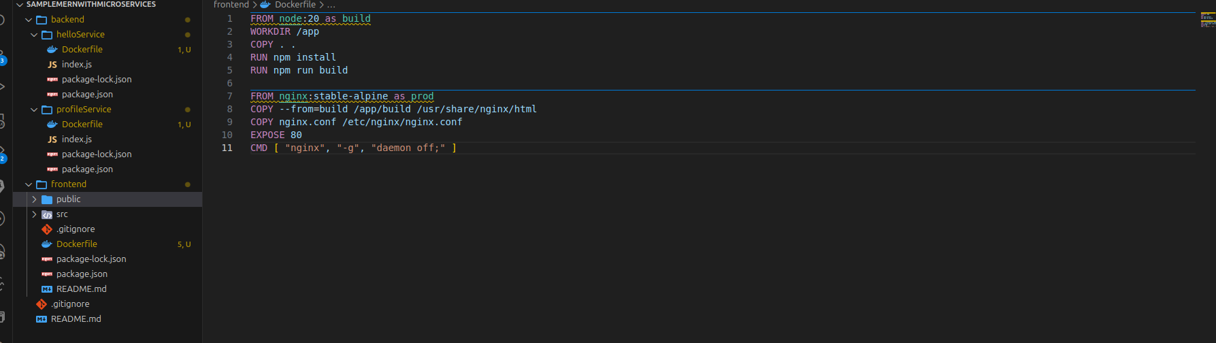

* Push Docker Images to Amazon ECR:

